AIM :- To study and implement the RSHash (Robert Sedgwick's Hash) function using Python.

PROGRAM:-

def RSHash(string):
a = 63689 b = 378551 hash_val = 0

for ch in string:
hash_val = hash_val * a + ord(ch) a = a * b

return hash_val % (2**32) # limit hash to 32 bits

text = input("Enter any text: ") print("RSHash Value:", RSHash(text))

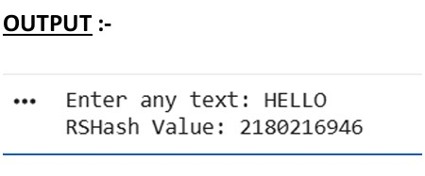
CONCLUSION :- RSHash is a simple and efficient hash function that generates a fixed-size numerical value for any input string.It is widely used for data lookup, hashing, and indexing, though it is not suitable for secure cryptographic applications.

